FORM 9
CERTIFICATE OF SUBSTANTIAL PERFORMANCE OF THE CONTRACT UNDER SECTION 32 OF THE ACT
Construction Act
 |  |  | Wellington North | ,
(County/District/Regional Municipality/Town/City in which premises are situated)
177, | 179 |  | , 181, 183 Jack's Way Mount Forest, ON N0G | 2L1 ,
(street address and city, town, etc., or, if there is no street address, the location of the premises)
This is to certify that the contract for the following improvement:
New Development - 6-unit townhome (including 2 basement apartments)
(short description of the improvement)
to the above premises was substantially performed on |  |  |  | July 9 2024 .
(date substantially performed)
Date certificate signed: July 10th, 2024
 |  |  | 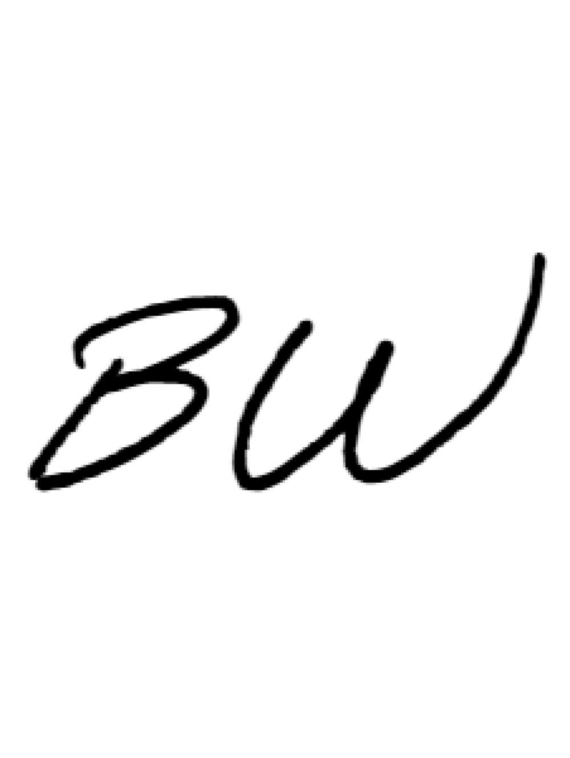  (payment certifier where there is one) | (owner and contractor, where there is no payment certifier)
Name of owner: 5053745 Ontario Inc.
Address for service: 237 Industrial Drive, Mount Forest, ON N0G 2L0
Name of contractor: 5053745 Ontario Inc.
Address for service: 237 Industrial Drive, Mount Forest, ON N0G 2L0
Name of payment certifier (where applicable): 5053745 Ontario Inc.
Address: 237 Industrial Drive, Mount Forest, ON N0G 2L0
(Use A or B, whichever is appropriate)
☐ | A. |  | Identification of premises for preservation of liens:  177 Jack's Way, 179 Jack's Way, 181 Jack's Way, 183 Jack's | Way - Mount Forest, ON N0G 2L1
(if a lien attaches to the premises, a legal description of the premises, including all property identifier numbers and addresses for the premises)
☐ | B. |  | Office to which claim for lien must be given to preserve lien:
 |  |  | (if the lien does not attach to the premises, the name and address of the person or body to whom the claim for lien must be given)

CA-9-E (2018/04)

